**Project 1**

DUE: November 6th, 2019

Professor: Stephen Lucci

CSC 30400

**Cool Team**

Pavlo Aleksyeyev

Hasibul Islam

Warin Wohab

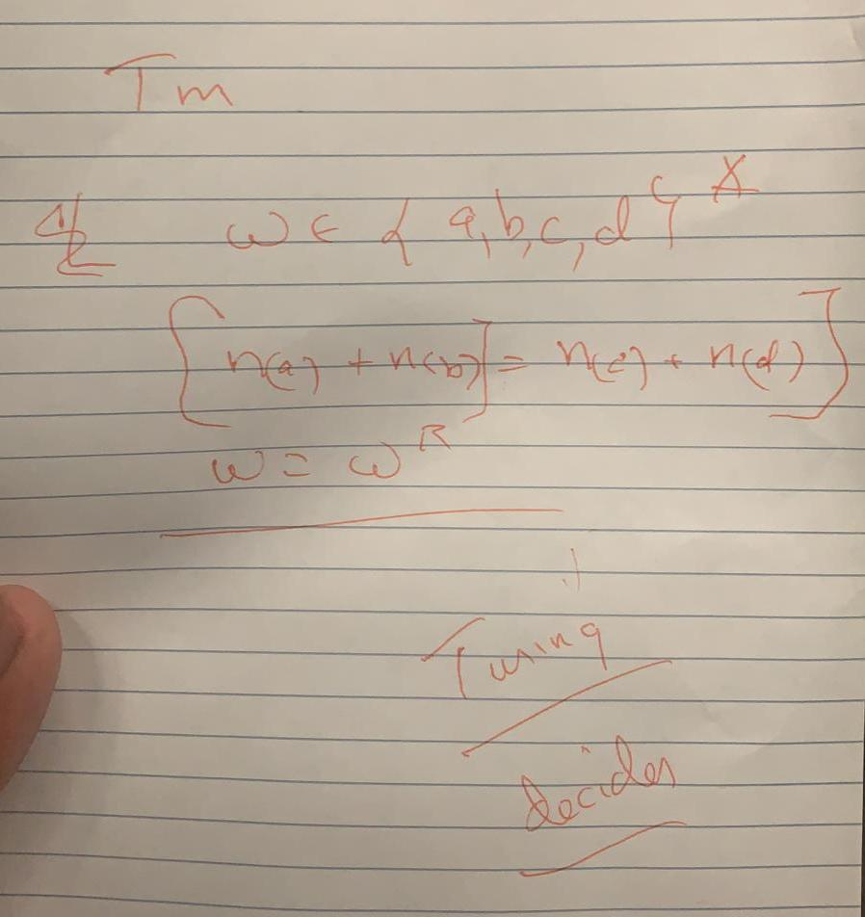

**Design Process:**

To begin with our design process, we decided to evaluate what the problem (task) was. Put simply, we needed to develop a Turing Decider that meet two specific conditions; n(a)+n(b) = n(c)+n(d), and w=wR (palindrome). We decided to make “sub Turing Machines” for each condition and then combine them for our final design. We were not sure how we would determine two conditions from one input, so we decided it would be the most efficient to have two copies, including the initial, and perform one condition per copy.

The first task was to design the Copying Turing Machine, our first “sub Turing Machine”. To do this we first designed this for the language w∊{a,b}* to simplify the process. We then added the necessary states for two more letters. Next we designed the Palindrome Turing Machine, which checks if a word, w, is a palindrome(w=wR). Again, we decided to start with a language where w∊{a,b}* to simplify the process, and then expanded it to work with letters c and d. This new “sub Turing Machine” was appended to the Copying Turing Machine so that the palindrome check would occur on the original input and not the copy. Then we created another “sub Turing Machine” that checked the condition, n(a)+n(b) = n(c)+n(d). To do this we designed a “sub Turing Machine” that finds the equivalency of two letters given a language w∊{a,b}*. To apply this to our Turing Machine design, our idea was to replace every a and b with an x, and every c and d with a y. Then we applied our Equivalency “sub Turing Machine” to determine if the number of x’s and y’s is equal. Finally we appended this “sub Turing Machine” to our main Turing Machine. The last part was to use Jflap to develop, test and run the Turing Machine.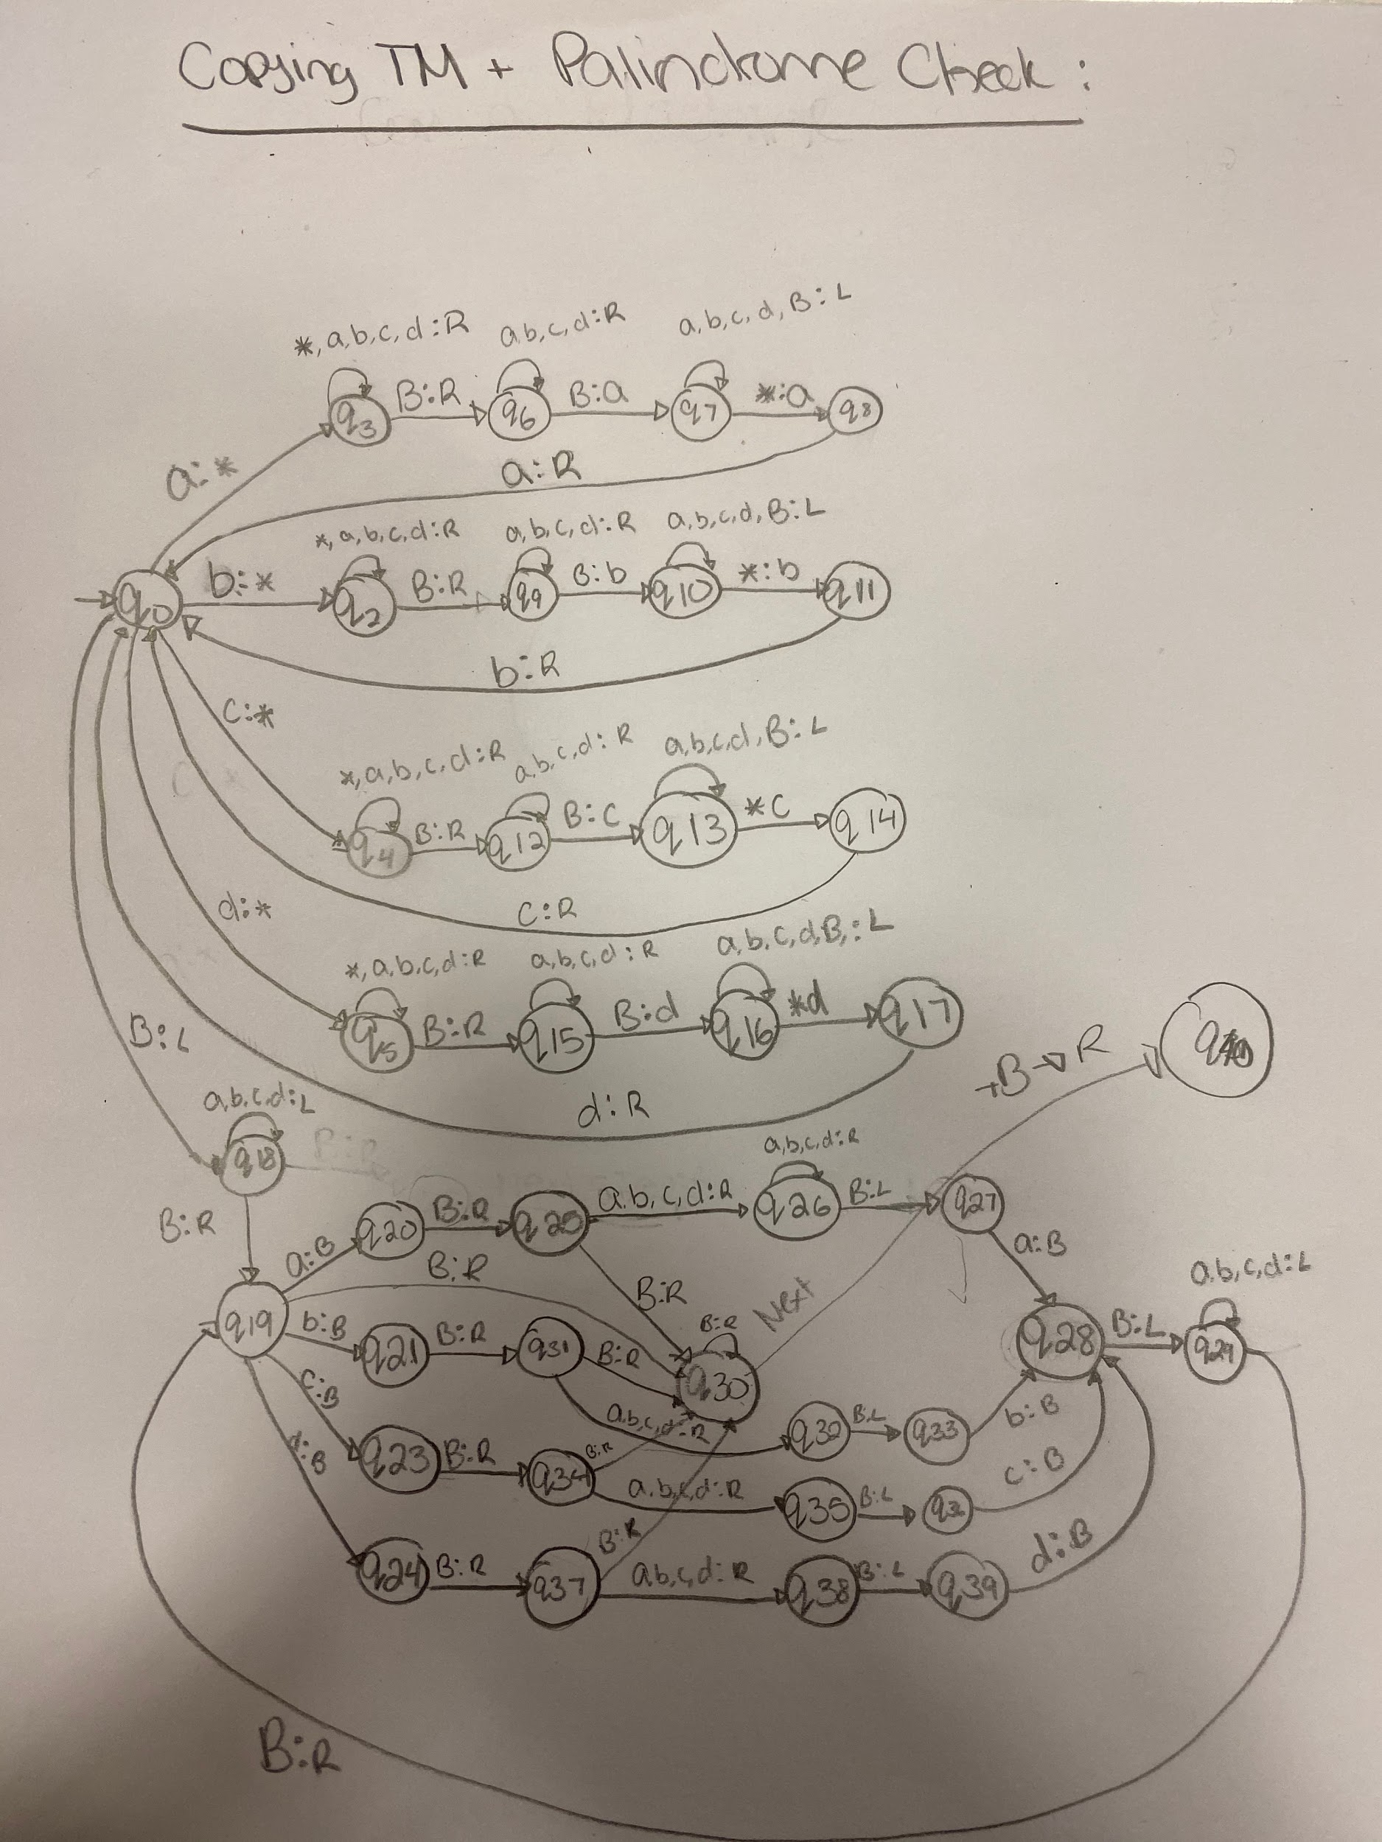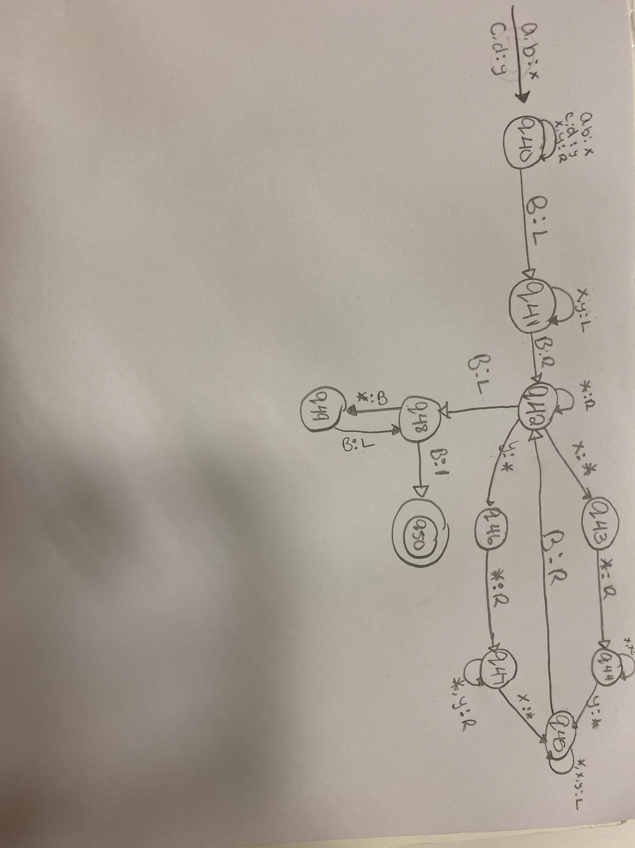

**Jflap Turing Machines:**

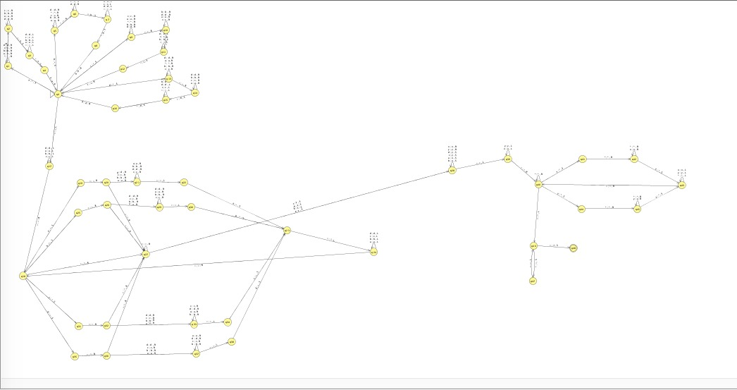

**Our Turing Machine**

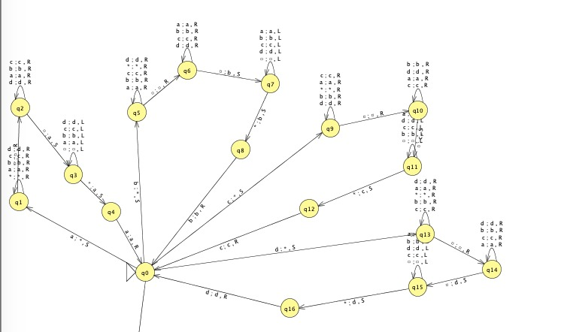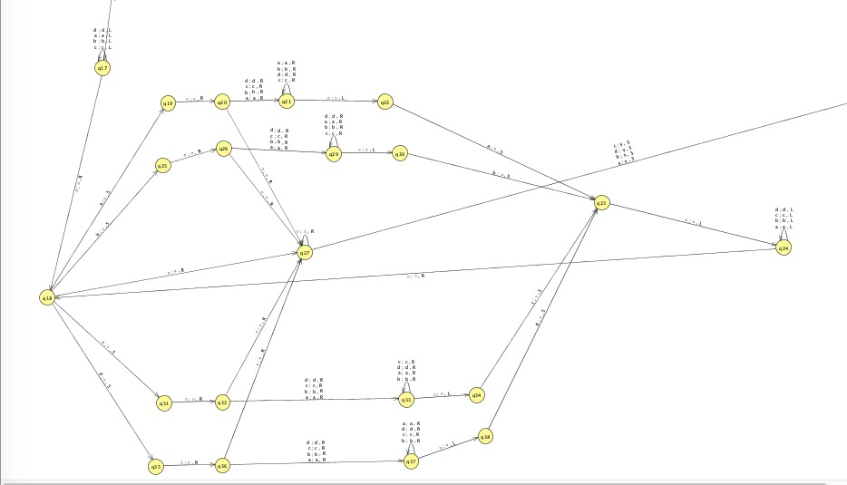

**Copying SubTuring Machine Palindrome SubTuring Machine**

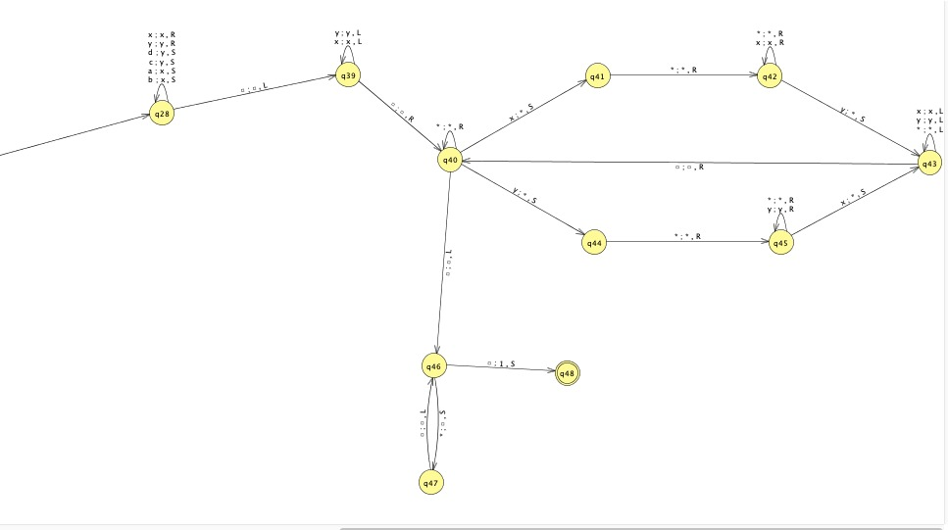

**Equivalency SubTuring Machine**

**Jflap Tests:**

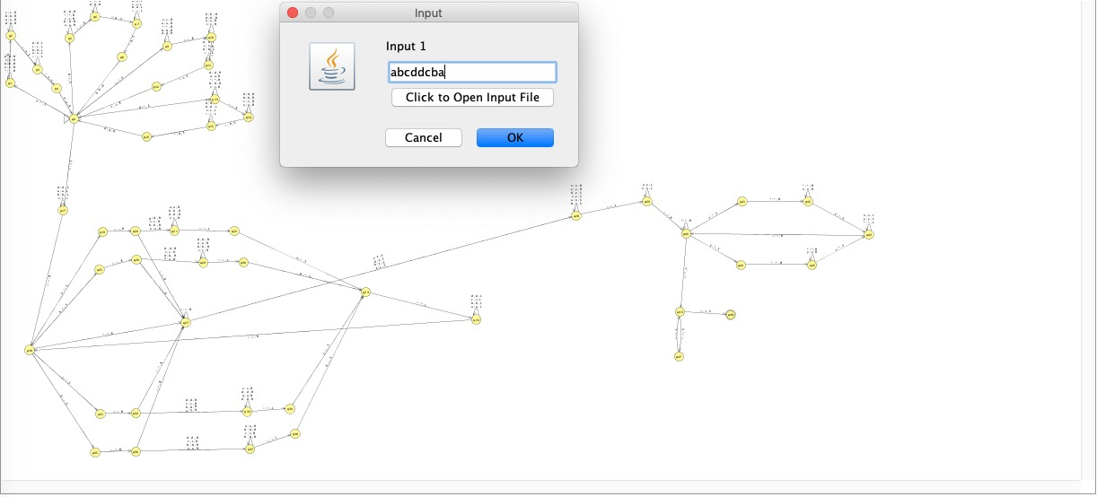

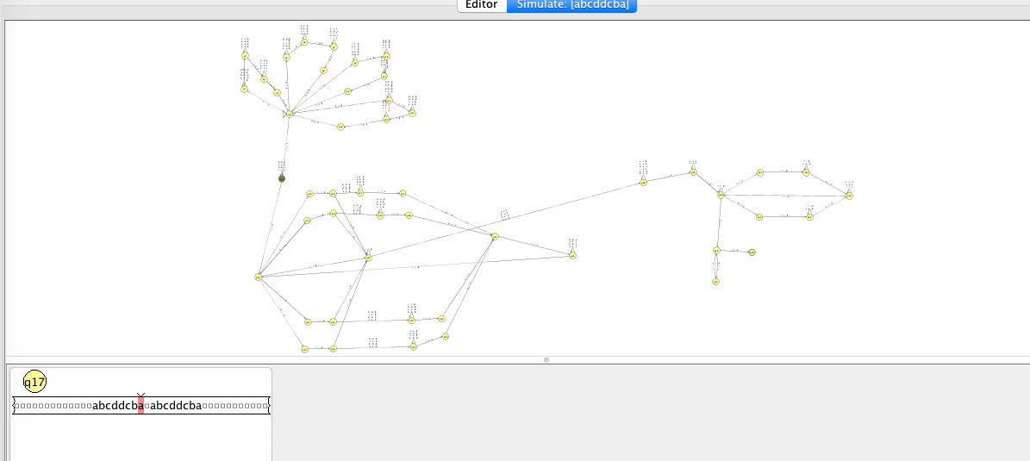

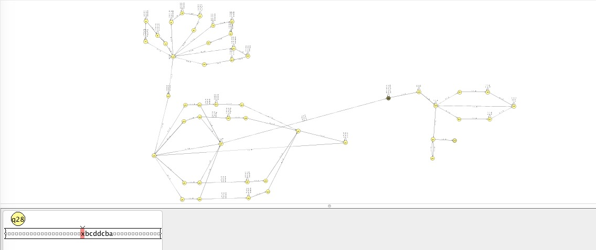

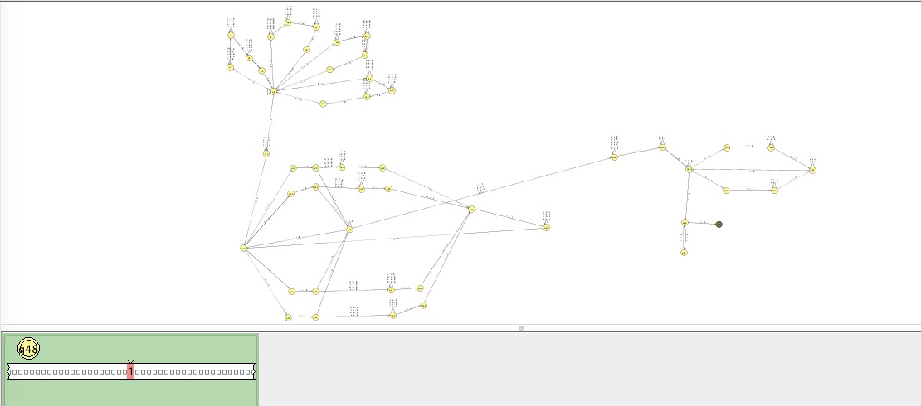

**Four More Test Results:**

